RIP Routing

**Configuring RIP in Packet Tracer**

1. Build the network topology.

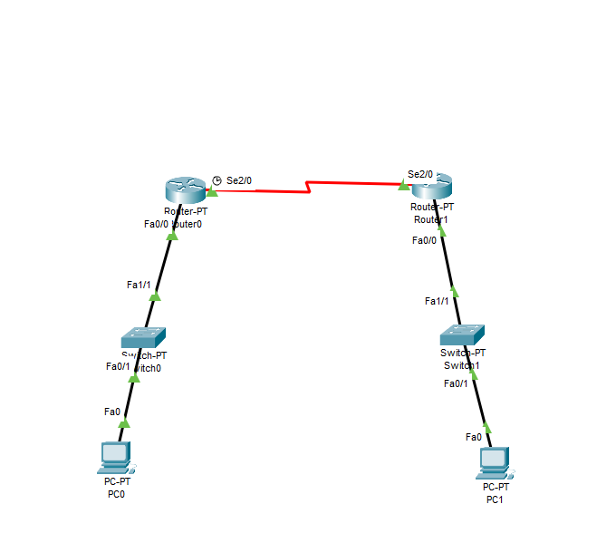

2. Configure IP addresses on the PCs and the routers.

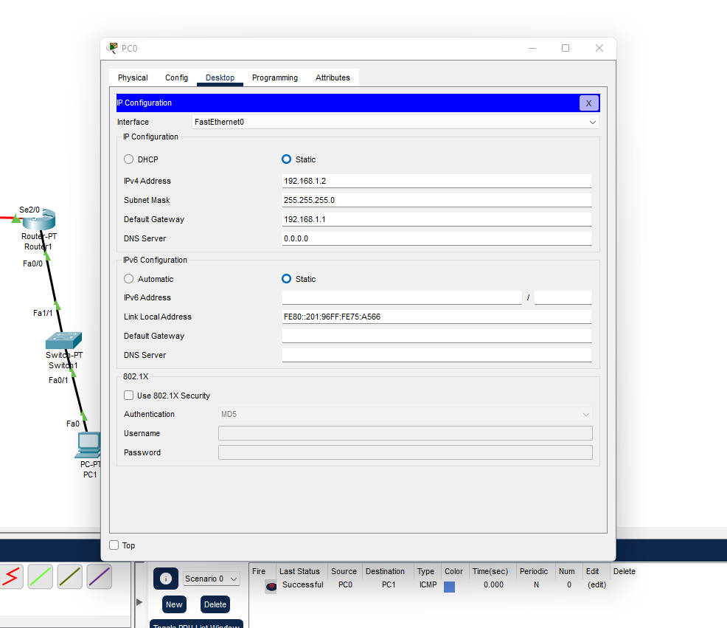

3. Configure **RIPv2** on the routers

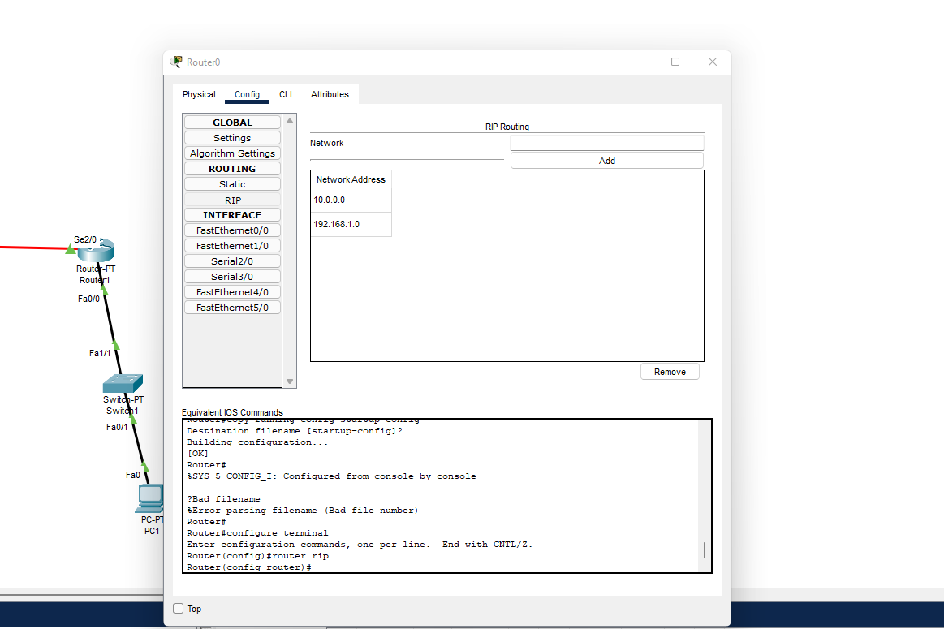

4. Simulation Checking

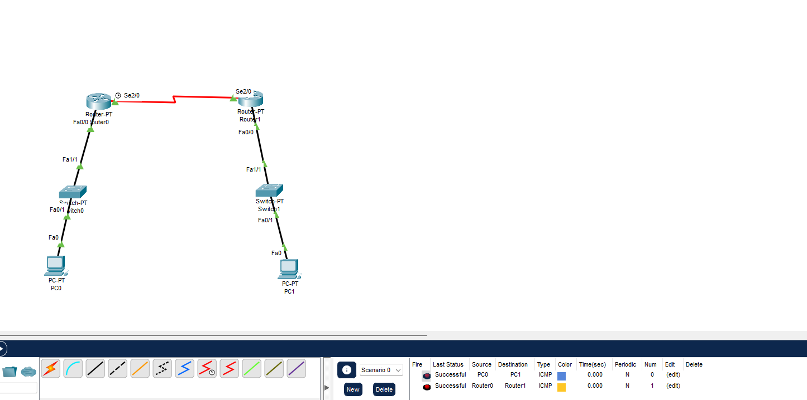

OSPF Routing

1. Build the network topology.

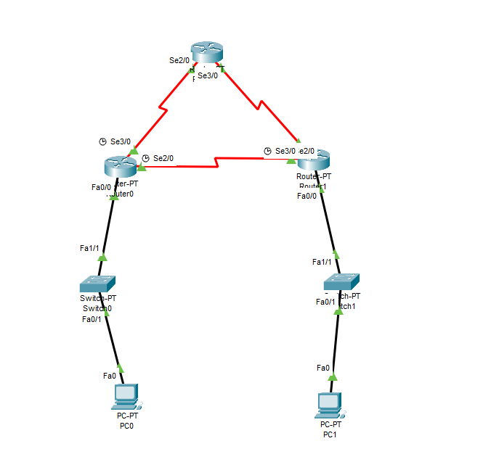

2. Configure IP addresses on the PCs and the routers.

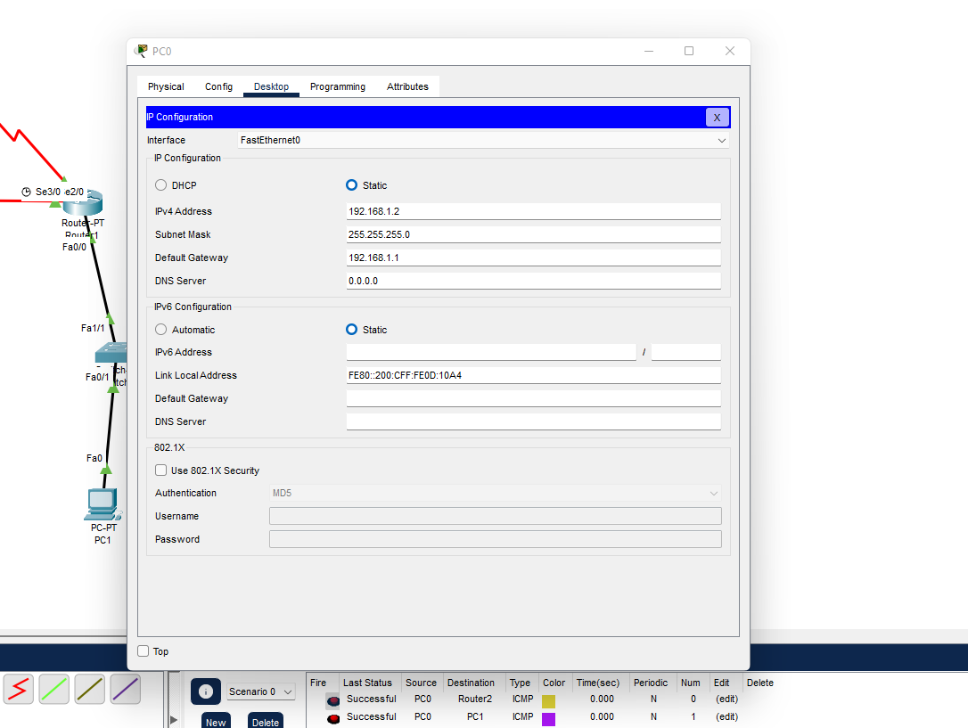

3. Simulation

